How to use GPS with Arduino - Parse and Log NMEA Sentences
By Aidan, updated on 22 November 2018
Now that we've investigated and explained how How GPS Receivers work we can apply that understanding to some real-world applications of of the ideas. To start, we can use any GPS receiver, an Arduino Uno and some male-to-female Jumper cables. We've chosen to go with Adafruit's Ultimate GPS Breakout module ; the Version 3 module that features 10Hz updates, 66 Channels and operates on 5V logic. We will look at using this board with the GPS Library from Adafruit and a typical Arduino IDE setup. We'll be downloading this library in the IDE and using the functions to manage the NMEA sentences our GPS breakout receives.
Let's set up our hardware first, everything we will do will work as long as we have the Tx/Rx pins attached between our two modules. So grab out all the parts you'll need, the Breakout board requires some soldering for the pin headers:
- Connect 5V from the Arduino to Vin on the GPS Breakout
- Connect GND to GND
- Connect the Rx Pin from the GPS Module to Digital Pin 2 on the Arduino
- Connect the Tx Pin from the GPS Module to Digital Pin 3 on the Arduino
- Connect the Arduino to your PC
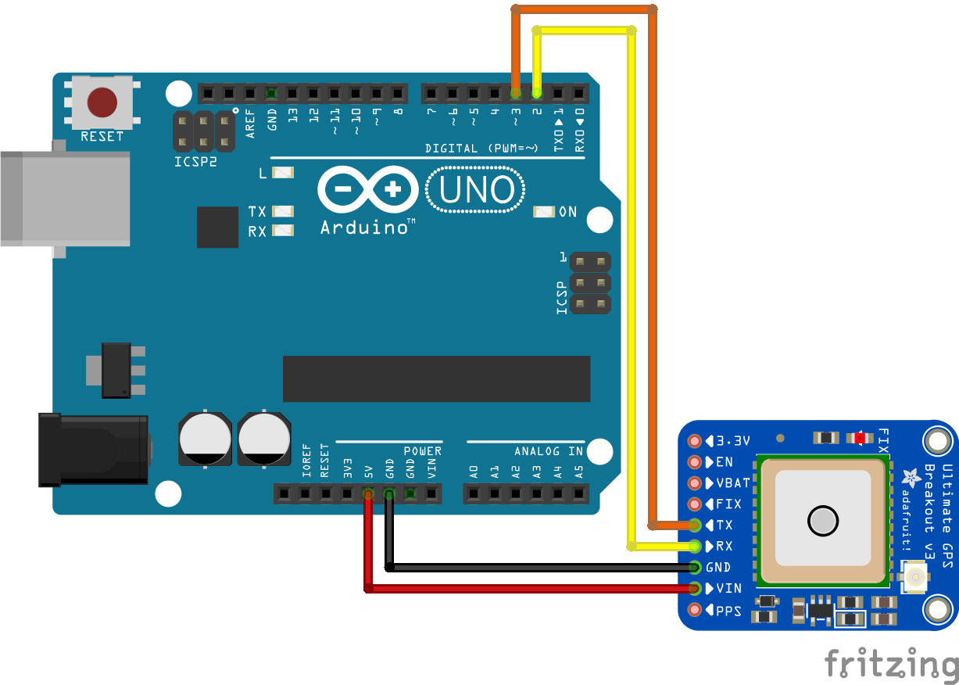
Setup your Arduino and GPS module in this way

GPS Library Essentials
To be able to leverage GPS data with the Arduino Uno we will need to include one library in our sketch:
- Adafruit GPS library - Open up your Arduino IDE and head to your Sketch > Include Library > Manage Libraries window. Search for GPS and select the option, "Adafruit GPS Library".
Use this code, see comments for more information
#include <Adafruit_GPS.h>
#include <Adafruit_GPS.h>
//We can now create our Software Serial object after including the library
SoftwareSerial mySerial(3, 2);

//And finally attach our Serial object pins to our GPS module
Adafruit_GPS GPS(&mySerial);

void setup() {
Serial.begin(115200); //This baud rate will help a lot in printing all of the data that comes from the GPS Module to the serial monitor
GPS.begin(9600);
//These lines configure the GPS Module
GPS.sendCommand(PMTK_SET_NMEA_OUTPUT_RMCGGA); //Sets output to only RMC and GGA sentences
GPS.sendCommand(PMTK_SET_NMEA_UPDATE_1HZ); //Sets the output to 1/second. If you want you can go higher/lower
GPS.sendCommand(PGCMD_ANTENNA); //Can report if antenna is connected or not
}

void loop() {
//Now we will start our GPS module, parse (break into parts) the Last NMEA sentence
GPS.parse(GPS.lastNMEA()); //This is going to parse the last NMEA sentence the Arduino has received, breaking it down into its constituent parts.
GPS.newNMEAreceived(); //This will return a boolean TRUE/FALSE depending on the case.
//Print the current date/time/etc
Serial.print("\nTime: ");
Serial.print(GPS.hour, DEC); Serial.print(':');
Serial.print(GPS.minute, DEC); Serial.print(':');
Serial.print(GPS.seconds, DEC); Serial.print('.');
Serial.println(GPS.milliseconds);
Serial.print("Date: ");
Serial.print(GPS.day, DEC); Serial.print('/');
Serial.print(GPS.month, DEC); Serial.print("/20");
Serial.println(GPS.year, DEC);
Serial.print("Fix: "); Serial.print((int)GPS.fix);
Serial.print(" quality: "); Serial.println((int)GPS.fixquality);
//If GPS module has a fix, line by line prints the GPS information
if (GPS.fix) {
Serial.print("Location: ");
Serial.print(GPS.latitude, 4); Serial.print(GPS.lat);
Serial.print(", ");
Serial.print(GPS.longitude, 4); Serial.println(GPS.lon);
Serial.print("Location (in degrees, works with Google Maps): ");
Serial.print(GPS.latitudeDegrees, 4);
Serial.print(", ");
Serial.println(GPS.longitudeDegrees, 4);
Serial.print("Speed (knots): "); Serial.println(GPS.speed);
Serial.print("Angle: "); Serial.println(GPS.angle);
Serial.print("Altitude: "); Serial.println(GPS.altitude);
Serial.print("Satellites: "); Serial.println((int)GPS.satellites);
}
}
So far our code has initialized the board to be able to read from our GPS module, and it was writing parsed data to the serial monitor!
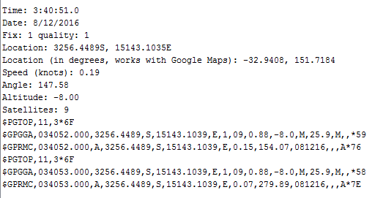
A Sample read of the Serial Monitor using the above code

Logging GPS Data
The Ultimate GPS board also has another feature we will take a look at. The Logging capability that is you can save GPS data to the internal storage and then access it at a later date. It collects your location data once/15 seconds and only while you have a fix. That's going to be particularly handy for recording GPS information in the future. To start logging with our module, we will need to use
GPS.LOCUS_StartLogger();
This function will begin logging data directly into the flash memory of the module. To get the module to dump our data once logged, we can use the following method:
- Upload the following sketch, File > Examples > Adafruit_GPS > locus_dump to your Arduino.
- Open the serial monitor
- Copy all the data under the --- line starting from the $ symbol below
- Paste the data into the Parsing field here
- You now have XML and KML data of your Logs that can to mapping software!
There you have it; now you know how to take GPS data from satellites and parse it using your Arduino. You can even log your data for any length of time using internal storage on the Ultimate GPS module. From here, you could utilise the recorded data by passing it to a GPS mapping application and trace out the path of your trip! All this from an Arduino and GPS Module, how cool is that?! Pick up your own Ultimate GPS Breakout if you haven't got one yet, they are the best way to use GPS! Used this tutorial for a project? Let us know in the comments below! We're always interested in hearing about the fun projects the community is up to! We hope this covered the essential information you needed to parse your NMEA sentences!

ntroduction: The Problem and Solution
Everyone knows that traffic jams can be a major time waster. And it is impossible to predict how long it would take from origin to destination.
The problem of traffic jams affected me when I came to a city two months ago. Every day I spend more than two hours stuck in jams. And I felt it like why can't I utilize this time to do something?
Note: I use public transport. :-)
There are plenty of other things you can do while being stuck in traffic jam!
Some of the ones below are not just fun, but productive too:
- Use the time to think and plan, either for current and future projects.
- Utilize time to educate yourself, watch instructional videos or take an e-learning course on Udemy, Coursera, etc.
And of course making electronics stuffs always inspires me. So I built a destination notifier using Arduino and GPS module. So what it does is whenever you are near to your destination, it notifies you by glowing LED or through vibration (by using mini vibrating motor). I have provided circuits for both LED and vibrating motor.
For that, first you need to find latitude and longitude to define the location. Once you find your location, you can use the latitude and longitude values to find distance to the location and by keeping a range you can turn on the notifier. The logic is simple, right?!
So let's get started.......

Parts and Tools:
To get started with your destination notifier, here are the required parts:
- Arduino UNO
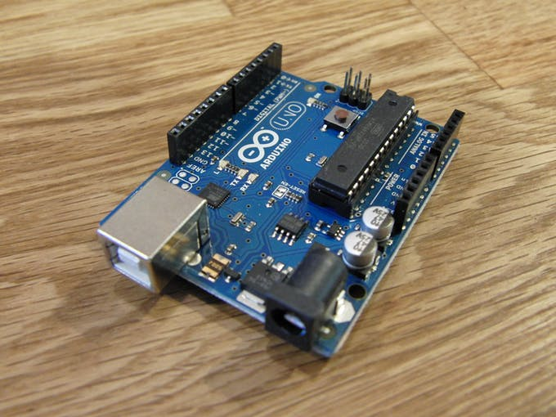The brains of this project
- NEO-6M GPS Module
GPS stands for global positioning system and can be used to determine position, time and speed if you are travelling.
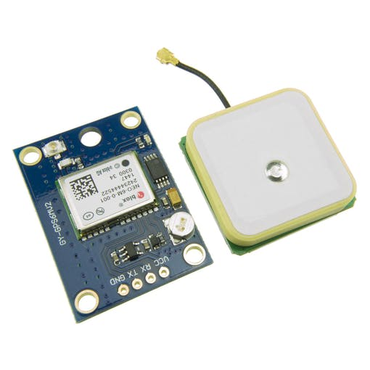NEO - 6M GPS Module
- This module has an external antenna and built-in EEPROM.
- Interface: RS232 TTL
- Power supply: 3V to 5V
- Default baudrate: 9600 bps
- Works with standard NMEA sentences
The NEO-6M GPS module has four pins: VCC, RX, TX, and GND. The module communicates with the Arduino via serial communication using the TX and RX pins, so the wiring couldn’t be simpler:
NEO-6M GPS ModuleWiring to Arduino UNO
VCC VIN
RX TX pin defined in the software serial
TX RX pin defined in the software serial
GND GND
L293D IC
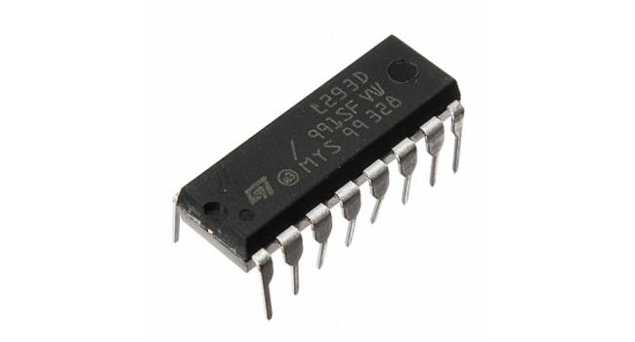
The L293D is a 16-pin motor driver IC which can control upto two DC motors simultaneously in any direction.
Why to use L293D?
The input to the motor driver IC or motor driver is a low current signal.The function of the circuit is to convert the low current signal to a high current signal.This high current signal is then given to the motor.
TinyGPS++ Library :
The TinyGPS++ library makes it simple to get information on location in a format that is useful and easy to understand.
The TinyGPS++ library allows you to get way more information than just the location, and in simple way, besides the location, you can get:
>>date
>>time
>>speed
>>course
>>altitude
>>satellites
>>hdop

Capturing Latitude and Longitude:
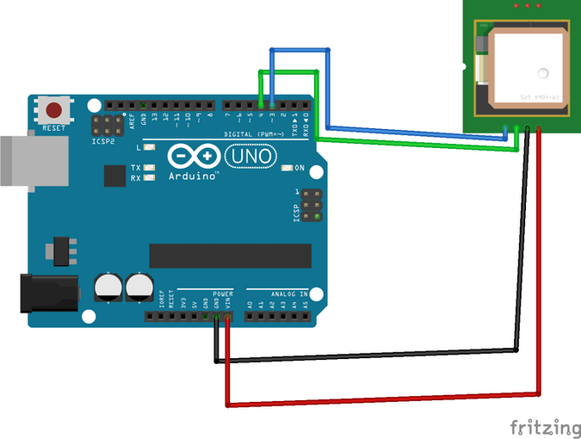Circuit diagram for Latitude and Longitude capture
I will suggest downloading fritzing files given on the end of the project for better clarification of connection or if you have any doubt feel free to ask in comments.

Arduino Code for Location Capture:
#include <TinyGPS++.h>
#include <SoftwareSerial.h>
static const int RXPin = 4, TXPin = 3;
static const uint32_t GPSBaud = 9600;
// The TinyGPS++ object
TinyGPSPlus gps;
// The serial connection to the GPS device
SoftwareSerial ss(RXPin, TXPin);
void setup(){
Serial.begin(9600);
ss.begin(GPSBaud);
}
void loop(){
// This sketch displays information every time a new sentence is correctly encoded.
while (ss.available() > 0){
gps.encode(ss.read());
if (gps.location.isUpdated()){
Serial.print("Latitude= ");
Serial.print(gps.location.lat(), 6);
Serial.print(" Longitude= ");
Serial.println(gps.location.lng(), 6);
}
}
}
Note: You must install TinyGPS++ Library
connect as per the circuit diagram and upload above code, Open serial monitor at a baud rate of 9600 and you will see the following output
Note: For getting latitude and longitude it may take some time.because the receiver need to capture the signals. whenever it starts getting signals the LED on the GPS module blinks.
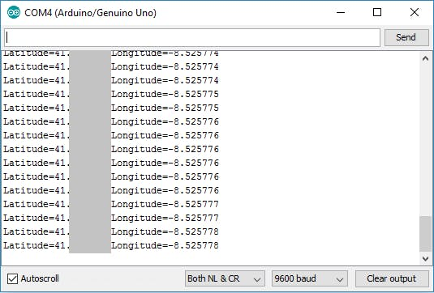Serial monitor output

Destination Notifier Through LED:
So to ensure that my idea works I made a prototype using LED to notify the destination. So what I did is, I added Latitude and Longitude values of destination from previous code(Read_Lat_Lng.ino) and found distance to destination from the current location. And used it for setting range at which the LED must turn on.
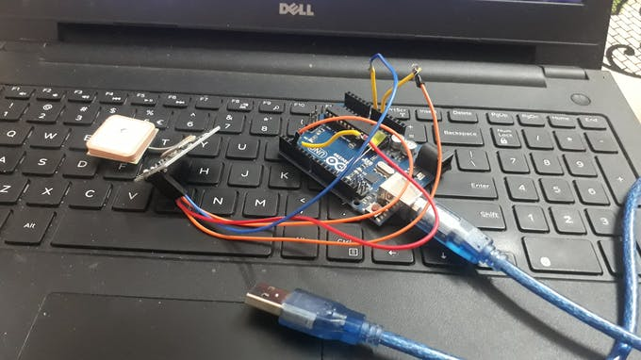
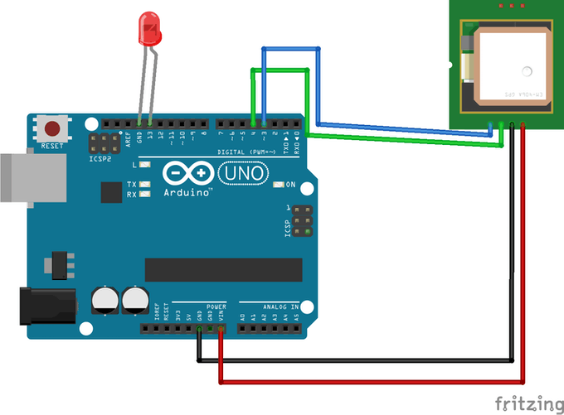

Code:
#include <TinyGPS++.h>
#include <SoftwareSerial.h>
static const int RXPin = 4, TXPin = 3;
static const uint32_t GPSBaud = 9600;
// The TinyGPS++ object
TinyGPSPlus gps;
// The serial connection to the GPS device
SoftwareSerial ss(RXPin, TXPin);
// For stats that happen every 5 seconds
unsigned long last = 0UL;
int ledPin = 13;
void setup()
{
Serial.begin(115200);
ss.begin(GPSBaud);
pinMode(ledPin, OUTPUT);
}
void loop()
{
// Dispatch incoming characters
while (ss.available() > 0)
gps.encode(ss.read());
if (gps.location.isUpdated())
{
Serial.print(F(" Lat="));
Serial.print(gps.location.lat(), 6);
Serial.print(F(" Long="));
Serial.println(gps.location.lng(), 6);
}
else if (millis() - last > 5000)
{
Serial.println();
if (gps.location.isValid())
{
// replace 'Dest_LAT' and 'Dest_LON' values basedon your location
// you can find Latitude and Longitude from Read_Lat_Lng.ino
static const double Dest_LAT = 18.786254, Dest_LON = 73.880798;
double distanceToDest =
TinyGPSPlus::distanceBetween(
gps.location.lat(),
gps.location.lng(),
Dest_LAT,
Dest_LON);
Serial.print(F("Distance to Destination ="));
Serial.print(distanceToDest/1000, 6); // *Prints distance to destination
if(distanceToDest/1000 < 0.050000) //Here when distanceToDest/1000 is less than 0.050000 LED turns on . So change *distance to destination as per your requirement.
{
digitalWrite(ledPin, HIGH);
}
else
{
digitalWrite(ledPin, LOW);
}
}
if (gps.charsProcessed() < 10)
Serial.println(F("WARNING: No GPS data. Check wiring."));
last = millis();
Serial.println();
}
}
Upload the code and you will see the following on the serial monitor.
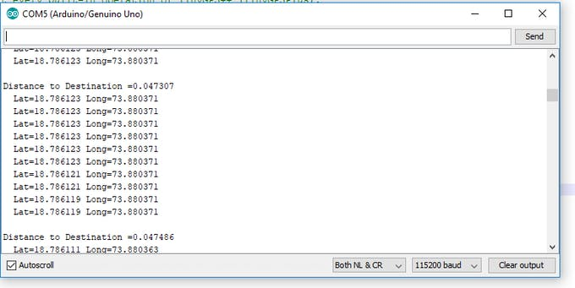
So the distance to destination can be used to define the range at which the output operation (notification) must perform.

The Final One!
OK my prototype worked fine. Now I want to enclose my project into a box which can fit an Arduino, GPS module, motor with driver IC, and the 9V power supply.
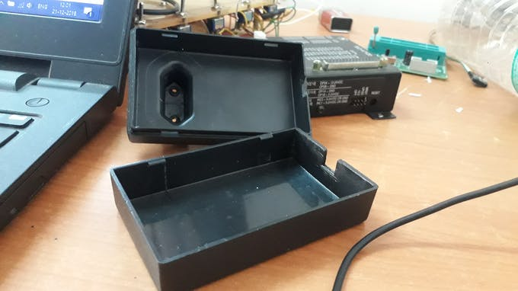enclosure from an old AC/DC Adapter
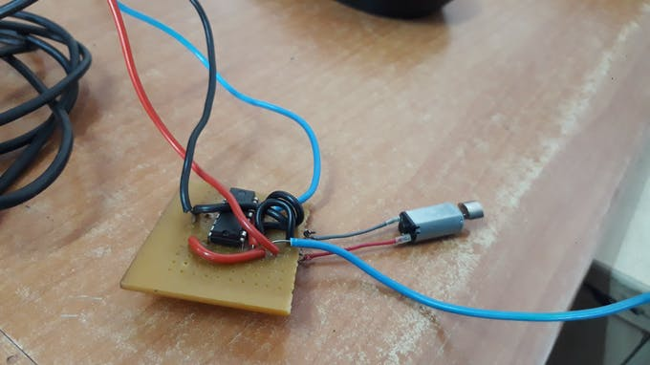Mini vibrating motor with L293D driver
Connection to the L293D IC
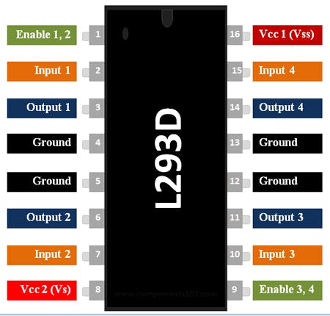
- Connect 5V to Enable 1, Vs and Vss on the L293D
- Connect digital output pins (we are using 6 and 7 ) to input 1 and input 2 on the L293D.
- Connect your Arduino's GND to both GND pins on the same side of the L293D
- Finally connect output 1 and output 2 of the L293D to your motor pins.
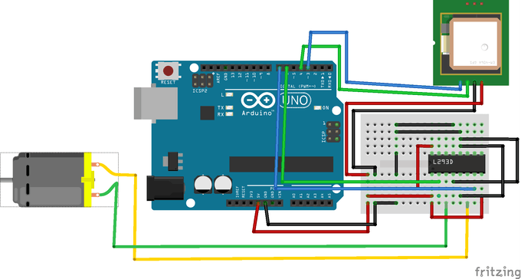

Code:
#include <TinyGPS++.h>
#include <SoftwareSerial.h>
static const int RXPin = 4, TXPin = 3;
static const uint32_t GPSBaud = 9600;
// The TinyGPS++ object
TinyGPSPlus gps;
// The serial connection to the GPS device
SoftwareSerial ss(RXPin, TXPin);
// For stats that happen every 5 seconds
unsigned long last = 0UL;
int motorpin1=6;
int motorpin2=7;
void setup()
{
Serial.begin(115200);
ss.begin(GPSBaud);
pinMode(motorpin1,OUTPUT);
pinMode(motorpin2,OUTPUT);
}
void loop()
{
// Dispatch incoming characters
while (ss.available() > 0)
gps.encode(ss.read());
if (gps.location.isUpdated())
{
Serial.print(F(" Lat="));
Serial.print(gps.location.lat(), 6);
Serial.print(F(" Long="));
Serial.println(gps.location.lng(), 6);
}
else if (millis() - last > 5000)
{
Serial.println();
if (gps.location.isValid())
{
// replace 'Dest_LAT' and 'Dest_LON' values based on your location
// you can find Latitude and Longitude from Read_Lat_Lng.ino
static const double Dest_LAT = 18.786254, Dest_LON = 73.880798;
double distanceToDest =
TinyGPSPlus::distanceBetween(
gps.location.lat(),
gps.location.lng(),
Dest_LAT,
Dest_LON);
Serial.print(F("Distance to Destination ="));
Serial.print(distanceToDest/1000, 6); // *Prints distance to destination
if(distanceToDest/1000 < 0.050000) //Here when distanceToDest/1000 is less than 0.050000 LED turns on . So change *distance to destination as per your requirement.
{
digitalWrite(motorpin1,LOW);
digitalWrite(motorpin2,HIGH);
}
else
{
digitalWrite(motorpin1,HIGH);
digitalWrite(motorpin2,HIGH);
}
}
if (gps.charsProcessed() < 10)
Serial.println(F("WARNING: No GPS data. Check wiring."));
last = millis();
Serial.println();
}
}
Happy making!

CODE
- Read_Lat_Lng.ino
- Destination_notifier_LED.ino
- Destination_notifier_motor.ino

Read_Lat_Lng.inoArduino

#include <TinyGPS++.h>
#include <SoftwareSerial.h>

static const int RXPin = 4, TXPin = 3;
static const uint32_t GPSBaud = 9600;

// The TinyGPS++ object
TinyGPSPlus gps;

// The serial connection to the GPS device
SoftwareSerial ss(RXPin, TXPin);

void setup(){
Serial.begin(9600);
ss.begin(GPSBaud);
}

void loop(){
// This sketch displays information every time a new sentence is correctly encoded.
while (ss.available() > 0){
gps.encode(ss.read());
if (gps.location.isUpdated()){
Serial.print("Latitude= ");
Serial.print(gps.location.lat(), 6);
Serial.print(" Longitude= ");
Serial.println(gps.location.lng(), 6);
}
}
}

SCHEMATICS

read_lat_lng_l3VSL54w0k.fzz
DOWNLOAD
read_lat_lng_l3VSL54w0k.fzz

destination_notifier_led_c7qaqTImXg.fzz
DOWNLOAD
destination_notifier_led_c7qaqTImXg.fzz

destination_notifier_motor_fGc8OV6Y0w.fzz
DOWNLOAD
destination_notifier_motor_fGc8OV6Y0w.fzz

COMMENTS
Please log in or sign up to comment.

Luis Barrales F.
2 years ago
Good Idea !. I have same problem here ...traffic here's awful.. and I spend a lot of time on public transport.. 😦


Amal Mathew
2 years ago
Thank you

Crazydrumstick
2 years ago
Nice tutorial!
I just made your prototype with the led notification, and it works like a charm 😃
I have one question th

Taking GPS data & comparing it to known range of coordinates; if match, display
Using ArduinoProgramming Questions
Feb 2015
8 / 9
Mar 2015
Mar 2015

system
Feb '15
PaulS: if(41.479133 <= Lat >= 41.493510 && -71.541359 <= Long >= -71.522058)
First piece of advice: Shitcan the stupid #define statements. The methods do NOT return a value that can be used this way.
Second piece of advice" Math class is over. This is programming. That is NOT how to test if a value is in some range.
Third piece of advice: Tell us where you think you have defined latitude and longitude. The compiler is telling you that you haven't defined them, and I can't see anything that suggests that it is wrong.
My initial idea was that by defining the "gps.f_get_position(&latitude)" as Lat and "gps.f_get_position(&longitude)" as Long, I would take the values of lat and long as supplied by the GPS and compare them to a respective range of coordinates. Therefore, if the obtained lat and long coordinates both matched their respective range, a message (for now, just the coordinates themselves) would be displayed on the Serial Monitor. My problem stems from the fact, that I do not know where/how to call the latitude and longitude values that the GPS is getting as the variable for the if statement.
#define Lat gps.f_get_position(&latitude)
#define Long gps.f_get_position(&longitude)
I believe I was obtaining an error message of latitude and longitude not being defined because Arduino does not know what the "(&latitude)" and "(&longitude)" within the "gps.f_get_position" statements is referring to. Which I find weird because when just trying to display the gps coordinates to the serial monitor it doesn't provide this error message. This is just an initial guess.
Lastly, if this current method isn't the best way of completing such a task, what way do you suggest being able to take the coordinates I am receiving and comparing them to the ranges I have written. Thank you.

johnwasser
Feb '15
Steve_P71: I believe I was obtaining an error message of latitude and longitude not being defined because Arduino does not know what the "(&latitude)" and "(&longitude)" within the "gps.f_get_position" statements is referring to. Which I find weird because when just trying to display the gps coordinates to the serial monitor it doesn't provide this error message. This is just an initial guess.
You have those two variables defined in the function that used to display on Serial Monitor. You apparently didn't declare the variables in the function where you tried to use the Lat and Long macros.

system
Feb '15
johnwasser: You have those two variables defined in the function that used to display on Serial Monitor. You apparently didn't declare the variables in the function where you tried to use the Lat and Long macros.
My question then is, what do I need to call to get the latitude and longitude values that the GPS is outputting? In my code I call:
float latitude, longitude;
and that seems to call the latitude and longitude data from the GPS. For the if statement, how would I call these same two parameters, or, what would the variable be that can reference that info?

johnwasser
Feb '15
Steve_P71: My question then is, what do I need to call to get the latitude and longitude values that the GPS is outputting? In my code I call:
float latitude, longitude;
That is not a call. It's a variable declaration. The variables, being local and uninitialized, contain garbage.
float latitude, longitude;
// Then call this function
gps.f_get_position(&latitude, &longitude);
THAT is a call. I recommend you use that call and then use 'latitude' and 'longitude' in place of your Lat and Long macros. And, of course, use the right syntax for comparing to limits:
if (41.479133 <= latitude && latitude <= 41.493510 &&
-71.541359 <= longitude && longitude <= -71.522058)

system
Feb '15
johnwasser: That is not a call. It's a variable declaration. The variables, being local and uninitialized, contain garbage.
float latitude, longitude;
// Then call this function
gps.f_get_position(&latitude, &longitude);
THAT is a call. I recommend you use that call and then use 'latitude' and 'longitude' in place of your Lat and Long macros. And, of course, use the right syntax for comparing to limits:
if (41.479133 <= latitude && latitude <= 41.493510 &&
-71.541359 <= longitude && longitude <= -71.522058)
I will try this and let you know if it works. Thank you!

system
Feb '15
johnwasser: That is not a call. It's a variable declaration. The variables, being local and uninitialized, contain garbage.
float latitude, longitude;
// Then call this function
gps.f_get_position(&latitude, &longitude);
THAT is a call. I recommend you use that call and then use 'latitude' and 'longitude' in place of your Lat and Long macros. And, of course, use the right syntax for comparing to limits:
if (41.479133 <= latitude && latitude <= 41.493510 &&
-71.541359 <= longitude && longitude <= -71.522058)
I have tried what I believed you were saying and I put my if statement after the gps.f_get_position function. My code now looks like this. Is this correct? When I compiled it, the error about defining latitude and longitude not in the scope went away. No errors found now. I will try and see if it works soon.
#include
#include

#define RXPIN 2
#define TXPIN 3

#define TERMBAUD 9600

#define GPSBAUD 4800

TinyGPS gps;

SoftwareSerial uart_gps(RXPIN, TXPIN);

void getgps(TinyGPS &gps);

void setup()
{

Serial.begin(TERMBAUD);

uart_gps.begin(GPSBAUD);

Serial.println("");
Serial.println("GPS Shield QuickStart Example Sketch v12");
Serial.println(" ...waiting for lock... ");
Serial.println("");
}

void loop()
{
while(uart_gps.available()) // While there is data on the RX pin...
{
int c = uart_gps.read(); // load the data into a variable...
if(gps.encode(c)) // if there is a new valid sentence...
{
getgps(gps); // then grab the data.
}
}
}

void getgps(TinyGPS &gps)
{

float latitude, longitude;

gps.f_get_position(&latitude, &longitude);

if (41.479133 <= latitude && latitude <= 41.493510 && -71.541359 <= longitude && longitude <= -71.522058)
{
Serial.print("Lat/Long: ");
Serial.print(latitude,5);
Serial.print(", ");
Serial.println(longitude,5);
}

}
Again, thank you for all your help and support. Still in the early learning process of how all of these components and Arduino coding works.

